PRESS RELEASE

Gayo Aviation Expands Operations to Norway with Dedicated Maritime Focus

Åkrehamn, Norway, 26 February 2026: Gayo Aviation, the innovative air charter and aircraft brokerage firm founded by Gisle Dueland, announced today the official launch of its new Norwegian office in Åkrehamn. This expansion marks the company's continued growth and commitment to providing exceptional aviation services to a wider range of clients, while emphasizing its dedication to the future of sustainable flight.
A History of Innovation and Sustainability:
Gayo Aviation is renowned for its innovative approach to the industry, consistently bringing new concepts to the market and championing sustainable practices. The company is actively involved in various initiatives aimed at reducing the environmental impact of aviation, making it a perfect partner for the environmentally conscious businesses within the Norwegian maritime sector.
Global Reach and Local Expertise:
Leading- and added Partner to the Norwegian office is Mr. Einar Tollaksvik, a successful local entrepreneur with extensive experience in the subsea- and maritime sector and a prominent figure in both local and international offshore wind initiatives. Mr. Tollaksvik joins a team of experienced brokers strategically located in Sweden, Poland, Lebanon, Dubai, Kosovo, and Saudi Arabia, ensuring Gayo Maritime Aviation offers a truly global reach with local expertise.
Understanding the Unique Needs of the Maritime Sector:
The Norwegian office, known as Gayo Maritime Aviation, will cater specifically to the unique needs of the maritime industry. Gisle Dueland, founder of Gayo Aviation, explains, "We are excited to bring our expertise and personalized service approach to the dynamic Norwegian maritime sector. Gayo Maritime Aviation will work closely with vessel owners, offshore and subsea operators, and shipyards to develop and deliver customized air charter solutions that seamlessly integrate with their operations."
Tailored Solutions and Seamless Operations:
Gayo Maritime Aviation's team of experienced professionals, both locally and globally, will offer a comprehensive range of services, including:
- On-demand air charter: Providing access to a diverse fleet of aircraft, from helicopters and executive jets to commercial airliners, to meet the specific requirements of each project.
- Flight logistics management: Ensuring seamless travel coordination, including permit acquisition, ground handling, and in-flight catering.
- Expert advice and guidance: Drawing on extensive industry knowledge to navigate complex regulations and identify the most cost-effective and efficient air travel solutions, while prioritizing sustainable options whenever possible.
Strategic Location in a Thriving Maritime Hub:
Gayo Maritime Aviation's strategic location in Åkrehamn, positions it perfectly to serve the needs of the region's thriving maritime industry. Situated in Haugalandet, Norway, one of the world's largest fleet-owning regions, Åkrehamn provides convenient access to key ports, shipyards, offshore installations and relevant stake holders. This central location allows Gayo Maritime Aviation to offer prompt and efficient service to clients throughout the region.
"We are confident that Gayo Maritime Aviation will become a valuable resource for the Norwegian maritime industry," concludes Tollaksvis. "We are committed to exceeding client expectations by delivering reliable, efficient, and cost-effective air travel solutions that support their success, while remaining mindful of our environmental responsibility."
About Gayo Aviation:
Founded in Sweden by Gisle Dueland, Gayo Aviation is a provider of air charter and corporate route development services, aircraft brokerage and aircraft management as well as being initiator and supporter of new sustainable flight concepts. With offices in Sweden, Dubai, and now Åkrehamn, Norway, and a network of experienced brokers spanning the globe, the company offers a diverse range of solutions tailored to meet the specific needs of its global clientele, while prioritizing a sustainable future for the aviation industry. For more information, please visit www.gayo.se

Media Contact:
Einar Tollaksvik, General Manager, Gayo Maritime Aviation Norway, +4790694490, einar@tollaksvik.no
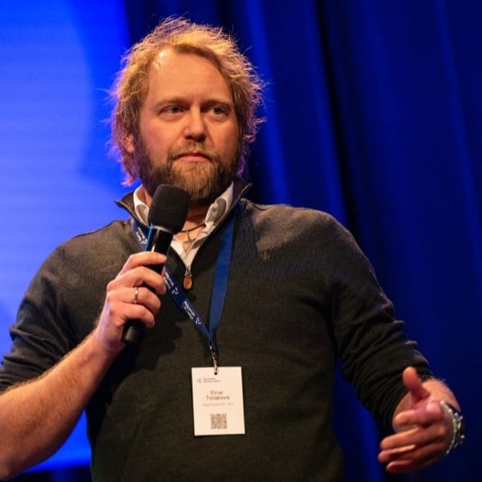

Gisle Dueland, CEO Gayo Aviation & Tourism, +46707926420, gisle@gayo.se,

